

Deliverable 4 - Design

Project C.A.T. - Capital Activity Tracker

Group: “The Stockings”

Clayton Williams, Kaitlyn Lee, Brandon Horner, Savannah Fischer

Course: CS 386 Software Engineering, Spring 2018

Instructor: Marco Gerosa

GitHub Link: <https://github.com/kdl222/CAT>

1. **Description**

CAT is a stock market analysis application that brings data visualizations and information-gathering together in an easily-accessible and affordable program, making it perfect for new and experienced stock traders alike. Equipped with live transaction suggestions and in-depth company evaluations, CAT allows traders to make more informed financial decisions than could be reliably accomplished alone.

Users can create a secure and private account on the CAT web application, where they can easily view and remove any stocks, and their accompanied real-time activity graphs, that they have selected to watch. The ranges of time covered by stock activity graphs can be adjusted to the user’s preference. Users can view a news feed containing many articles. Users can add and remove keywords in a keyword manager, set the weight of each word, and watch as the manager parses through the news feed to show the net weight of each article.

1. **Verification (tests)**
   1. **Unit Test**

For the unit test, we decided to test the Stock class. Because it uses the StockData class, we created a mock object and made sure that the stock class can be populated and accessed.

* 1. **Integration Test**

For our integration test, we tested our StockMarketModel, Stock, and StockData. We started by creating an object of the StockMarketModel, which will grab all stocks from the API was use to get our stock information. We then created a Stock object and initialized it to the first stock in the StockMarketModel object. We then verified that the first stock’s daily class variable was not null.

**Both the unit and integration tests were executed at the same time, so they are in the same screenshot. They are also in the same file**

<https://github.com/kdl222/CAT/blob/dev/project/CAT/src/app/stocks-page/stocks-page.component.spec.ts>

Terminal Output:

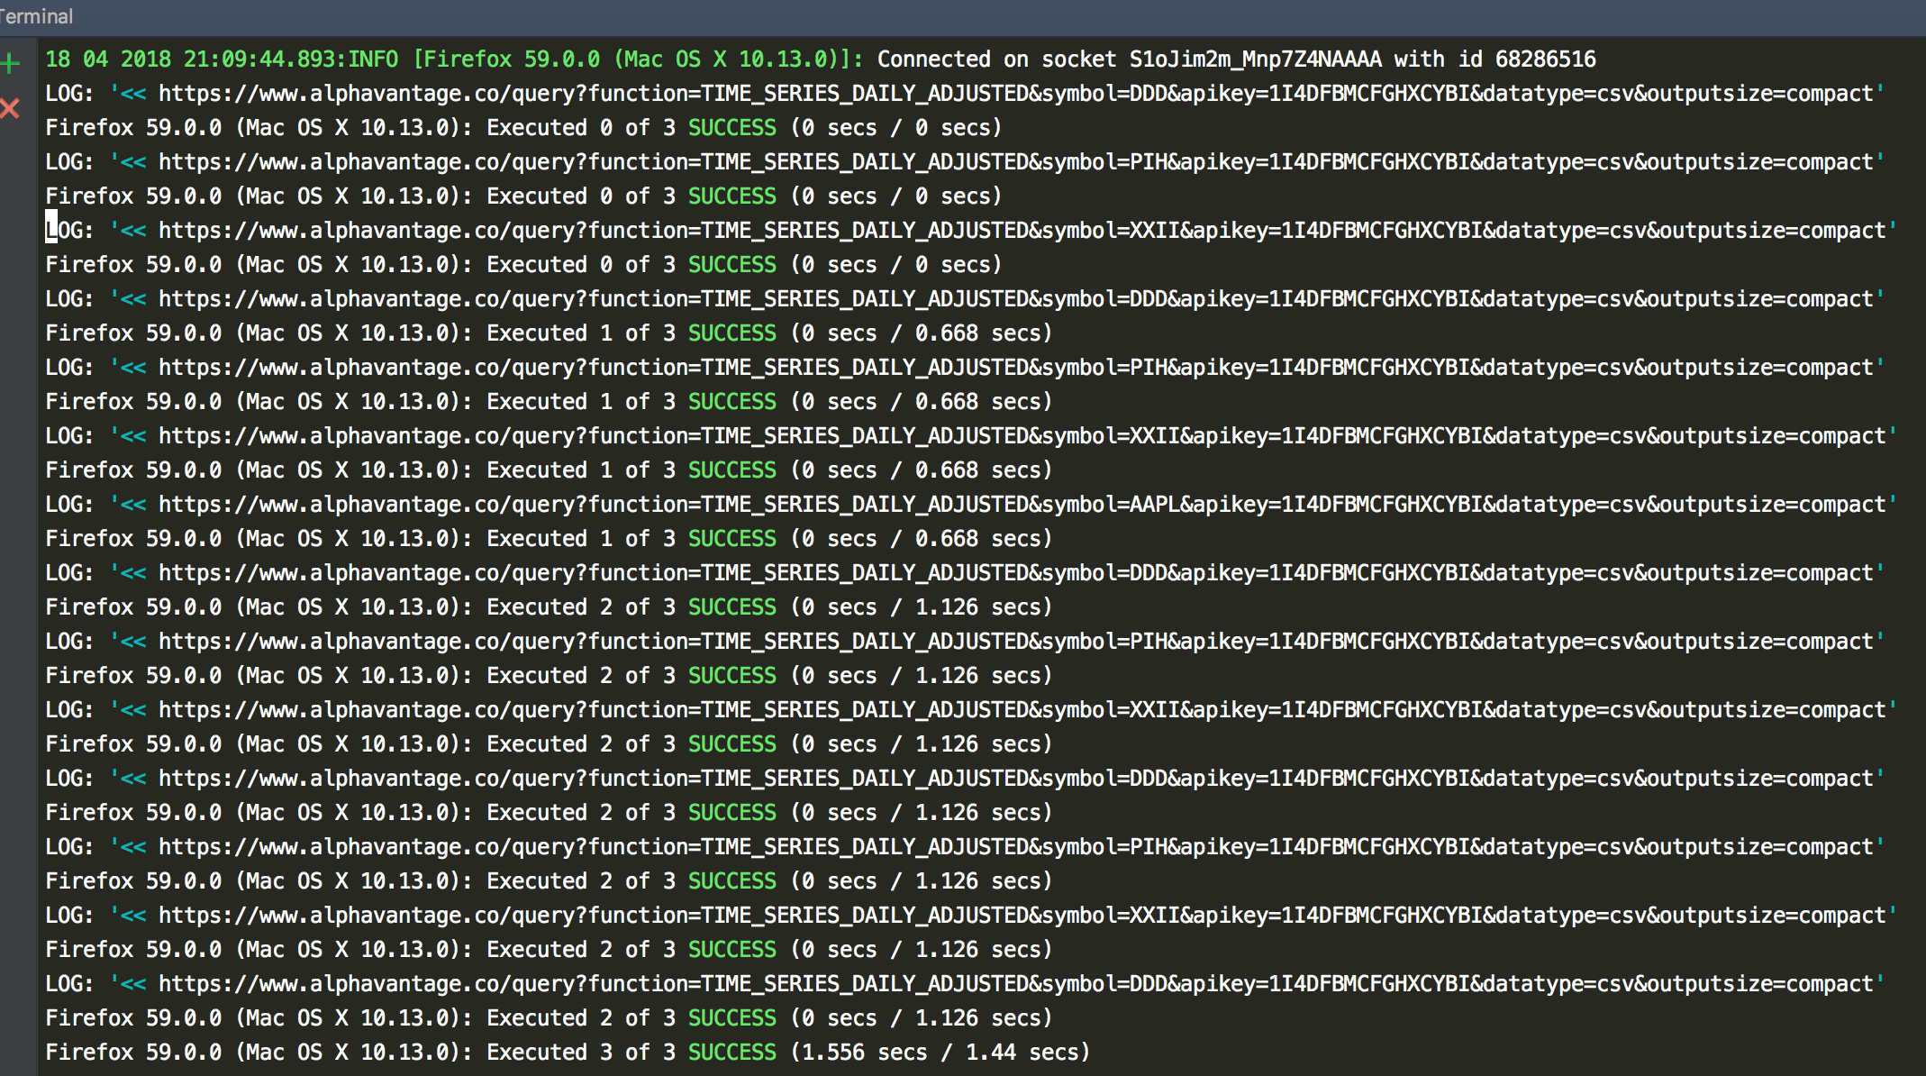

Karma Output (Angular’s way of displaying test results without the terminal):

The 3 “specs” are our tests

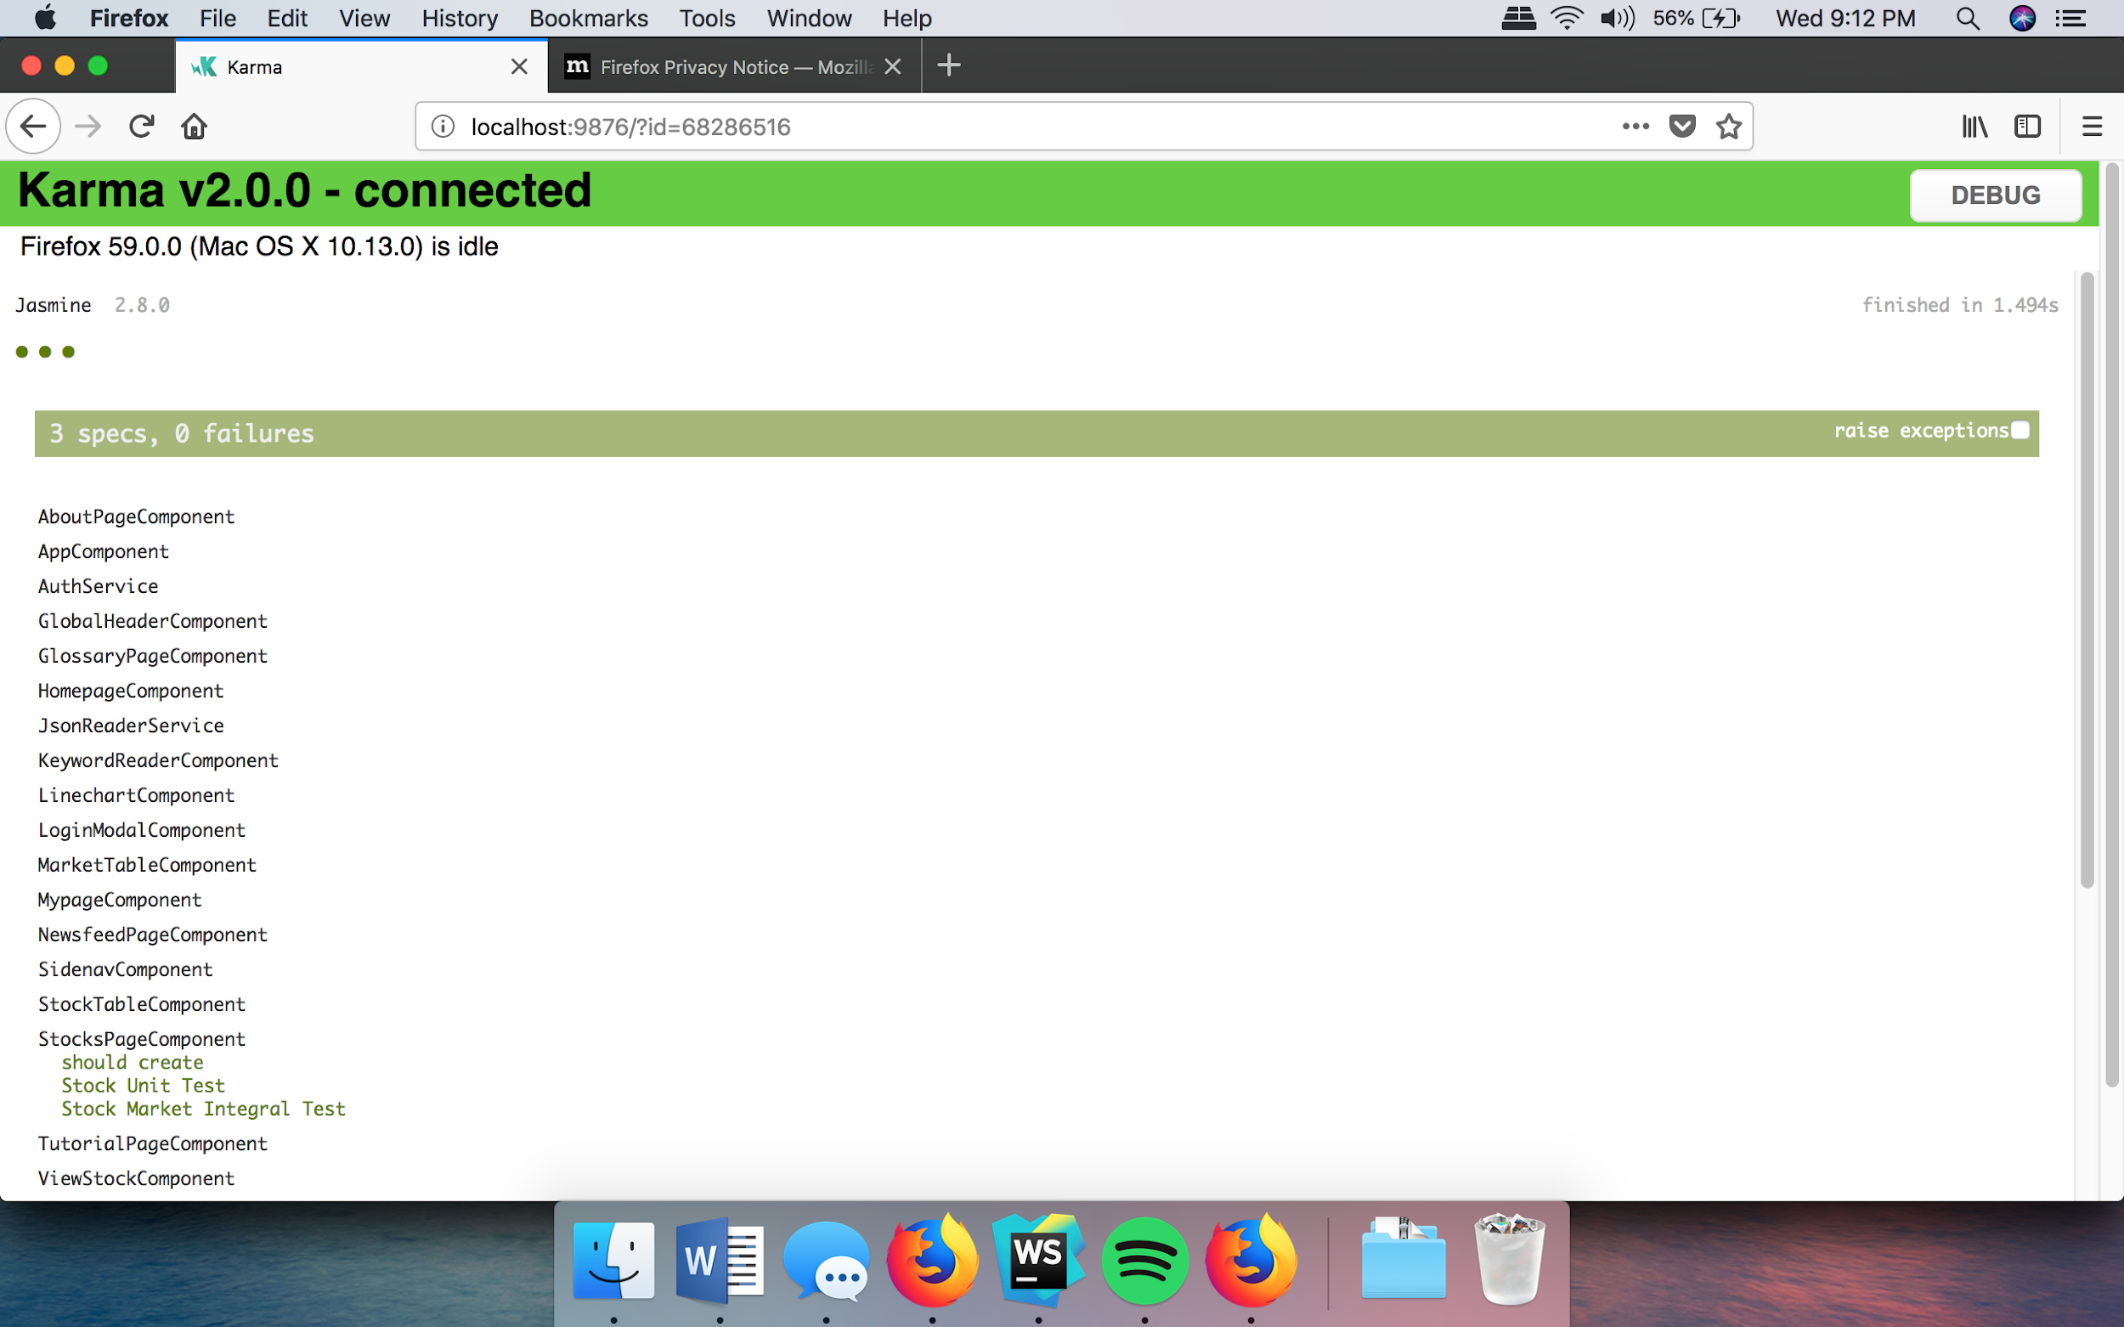

* 1. **Acceptance**

When trying to run an automated acceptance test, our system kept failing because of the use of a routing module that allows our web application to navigate to different pages. This error comes up no matter if we just run a simple test of 1+1=2. We have tried all solutions found online about adding imports and exports to our components. None of these solutions seemed to work. This is something completely out of our control. We have supplied a screenshot of the simple 1+1=2 test and an AppComponent ( the main page of our web application) test that should pass since our web application is working.

Even though this test is failing, our web application still works just fine. We talked to Dr. Gerosa after class about our issue, and he told us to link a video of us testing our system instead.

Link to video:

<https://drive.google.com/file/d/1sTIUgkFsmuPEXMZBqzGqfWuSUhyEKM_f/view?usp=sharing>

All of the pages load and the sign-in feature works. The stocks page loads slowly because it is loading all stocks from our API, but we are working on fixing this.

1. **Validation (user evaluation)**
   1. **Script**

* Provide the user with the homepage of our website
  + Ask about initial reactions of the homepage
  + Is it clear what the product is?
    - Ask them to elaborate
* Task the user to log in with their google account (How long did it take)
  + Ask how they feel about the log-in setup
  + How does the profile page feel?
    - Does the web page appear to line up with their expectations?
* Task the User to navigate the site’s navigation bar (How long did it take)
  + Does the web page appear to line up with their expectations?
  + What do they like about each page?
  + What do they dislike about each page?
    - What would they change about each page?
* Task the user to navigate to the Glossary page (How long did it take)
  + Are there words that should or should not be on the page
  + Does the web page appear to line up with their expectations?
* Task the user to navigate to the News Feed page
  + Task user to sort through news articles using keywords and company names
  + Does the web page appear to line up with their expectations?
  1. **Results**

1. Chris Moore, male, age 20

* The user’s initial reaction to the homepage was that it was visually appealing; the contrast between the dark background and the white text was pleasant. The product’s purpose, detailed in the concise product description paragraph, was clear.
* Signing in with a Google account was not possible with the current page setup, though the location to do so was easy to navigate to; upon signing in, the profile page showed the name of the owner of the computer used, instead of the name saved in the user’s gmail account. Other attempts to log in were met with a blank screen before the user had the ability to actually sign in.
* Navigation bar was easy to locate. For the Glossary page, the user found that the text should have been darker and/or bolder. It would have been best if the letters in that page’s navigation bar actually mapped to the letters of the alphabetical introductions. He enjoyed that each term was defined concisely and that there was a letter navigation bar to begin with. For the Newsfeed page, the user is looking forward to the actual incorporation of data. The layout was pleasant, though. For the ‘What are Stocks?’ introduction page, a nice beginner description of stock market trading was provided. His favorite part included the recommendation section. The advice was good and gave an insight into the company’s values. He enjoyed that the stock page kept users up to date with recent articles and showed live stock group information (such as the NASDAQ value). Data pulling still needs to be accomplished, though, and the graph function will be much appreciated.
* Glossary page was navigated to easily. User expectations of a Glossary page from our web application were met; Word definitions were relatively concise, though the page was larger than they expected. The words present in the glossary were informative and they all seemed to belong where they were placed. The alphabetical organization of the page was appreciated.
* Newsfeed page is still under development, but user found that the temporary placement items are where they should be and that the layout when it actually pulls data will be attractive.

**Conclusion:** The implementation of data parsing and pulling should be a priority. The learning curve of the system appears, at the present time, very mild; the different sections of the site appear to do as they say (or hint at soon being able to accomplish what they imply). The user performed the tasks given in a way that was expected, but, one manner in which their attempts gave unexpected results was in how they attempted to log in with our site’s log in function. The log in function appeared not to work when done straight from the site, which will definitely need to be addressed. The user liked most that the information the needed was presented in a concise manner and in an attractive way. The value proposition of our site, as it currently is, was not met - as some necessary functionality is missing.

2) Denyce Soird, female, age 21

* The user’s initial reaction to the homepage was that the value proposition was very prominent, eye-catching, and attractive. She found that the lack of picture-based links on the bottom feature descriptions was disappointing. Otherwise, she enjoyed the front page greatly and found the purpose of the product, as a web application designed to assist in stock graph/news analysis to be clear.
* The user was able to quickly log in with her google account. She found the ideas displayed in the profile page, still under construction, very pleasant. She thought that the ability to track her favorite stocks and view their graphs within a set range directly from the profile page to be really nice, as well as the ability to view articles related to the stock currently displayed. She was not sure what to expect with a profile page on a stock site, but like what we had decided to include.
* The user quickly found the navigation bar and found it easy to move to each page in the site, as they expected to be able to. She enjoyed the glossary page, but had a problem with the text. She felt that the news feed page had potential but wasn’t comfortable forming a strong opinion about it as it was unfinished. She liked the idea of the stocks page, especially the live stock analysis. She felt, however, that the page was a little busy, and that articles should be unincluded.
* Regarding the Glossary page, the user liked the amount of terms that were available to her, and found the page to be like a traditional glossary (as she expected and as the developers intended) many that she was uncertain of how to define herself. She disliked the size of the text used to define the words and how the text was hard to read.
* Regarding the News Feed page, the user liked the idea that was presented with the page (still under construction). That she would be able to navigate articles based on keywords and company names was quite appealing to her. Without more work put into the page and without the data parsing feature, she felt unable to make any more statements.

**Conclusion:** Finishing the News Feed and Stock pages should be the focus of the development team. The user found the site easy to use and to navigate and the page names self-explanatory. The user performed the tasks given in a way that was expected with the expected results. The user liked most that the ‘New to Stocks?’ page offered relevant recommendations that gave her a greater understanding of what to look out for when trading with stocks. The value proposition of our site, as it currently is, was not met - as some necessary functionality is missing.

3) Tyler Jackson, male, age 18

* The user’s initial reaction to the homepage was that the value proposition and navigation bar took up the entirety of the window the user first sees when opening our product site. He didn’t feel that it was a bad thing, but that the features presented below were made almost unimportant and repetitive. He did like, however, that he knew, at first glance, exactly what the site was about and what it meant to do based on that small amount of text.
* The user was able to log in with his google account. He didn’t like how the profile page text was so thin and unassuming and how there was a distinct lack of color to the page (disregarding the temporary graph picture). He liked what the profile page promised, though, and found the idea of saving his favorite stocks for quick and easy access very appealing.
* The navigation bar was very prominent, and the user had no trouble using it. He liked the Glossary page’s information, but found the page to be ‘hard on the eyes’. He suggested the use of a darker font. He liked the idea of the News Feed page, but was unimpressed by its current design and offered a suggestion for its change. The user found the stocks page to be alright, but thought that relevant articles should be moved down to the bottom of the page and the primary focus to be on the stocks themselves. He suggested a hover feature, where the user would hover their mouse over the name of a stock presented and the graph would expand from it (so long as the user hovered their mouse above it). He also believed that the live action stock analysis that we have already implemented was a nice touch.
* The user easily navigated to the Glossary page. He liked the amount of information we had to present, but he didn’t like how close the definitions were to each other. He argued spacing would make the page look better, as well as a change in text color and size so that the user could better read what was on the page with less eye-strain.
* The user quickly moved to the News Feed page. He liked what we were planning to implement but didn’t like the layout much. Instead of the blocks that would currently hold the articles, he thought it would be better if the article pages were set up like a google search page, with the name of the article highlighted and the items moving down a list. He also thought the page to be a little bland, and wouldn’t mind seeing more items placed on the page (besides articles). He did not know how to explain his reasoning, other than the white of the page was ‘a little too much’.

**Conclusion:** This user had many interesting ideas of how to make the product site better, but finishing the completion of the items outlined in our value proposition should come first. All in all, our site was easy for him to use and to navigate, especially if the pages under construction eventually do what they say and as easily as their current layouts imply. The user performed the tasks given in a way that was expected and with the expected results. The user liked most that we would be implementing data parsing to our site and was excited to see our final stock page once stocks could truly be analyzed and observed. The value proposition of our site, as it currently is, was not met - as some necessary functionality is missing.

1. **Group Participation**

**Kaitlyn Lee:** (Created unit and integration tests, troubleshooted Karma testing and recorded video) **45%**

**Brandon Horner:** (Worked on interview script) **15%**

**Savannah Fischer:** (Created description, worked on interview script and troubleshooted Karma testing application for Angular 5. Performed interviews): **40%**

**Clayton Williams:** **0%**